Former site of Mastex Industries chosen as home for Holyoke's high performance computing center
Springfield Republican: Published: Monday, August 09, 2010, 9:58 AM Updated: Monday, August 09, 2010, 1:51 PM
Mike Plaisance, The Republican
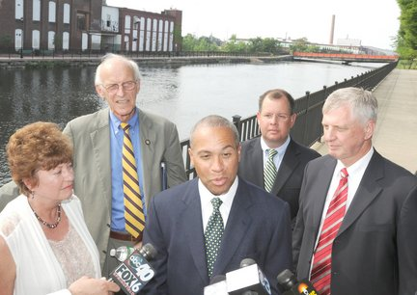
HOLYOKE – Optimism flowed like the water in the canals that served as the backdrop for Gov. Deval L. Patrick’s announcement here on Monday that the high performance computing center will be built at the former Mastex Industries Inc. facility on Bigelow Street.
Mark M. Murray / The Republican 08.09.2010 | HOLYOKE - Governor Deval L.Patrick, center, speaks at Heritage State Park in Holyoke to announce the site of the Holyoke high performance computing center. Looking on are Holyoke Mayor Elaine A. Pluta, left, Congressman John W. Olver (D-Amherst), State Rep. Michael Kane, and University of Massachusetts President Jack M. Wilson, right.
Patrick said the blazing-fast, world-class research center will be “one of the most exciting developments in Western Massachusetts.”
“It is a great day in the pursuit of knowledge and innovation,” said Jack M. Wilson, president of the University of Massachusetts.
“I’m expecting great things from this project,” Mayor Elaine A. Pluta said.
Public identification of the site comes 13 months after Patrick, in a presentation at the Holyoke Public Library, announced the center would be built at the canals to take advantage of the cheap energy and cooling powers of the hydroelectric dam owned by the Holyoke Gas and Electric Department.
The project will entail an investment of at least $168 million from the partners that have formed under the nonprofit Massachusetts Green High Performance Computing Center Inc., of which Wilson is board chairman, Wilson said.
The cost figure from Wilson was the highest yet for a project that had been described as a venture of at least $100 million.
Previously, officials said that the consortium of five colleges in the project had committed $105 million, consisting of $65 million in equipment for the center and $40 million for other costs. Patrick has pledged $25 million in state funds to ensure construction begins by fall.
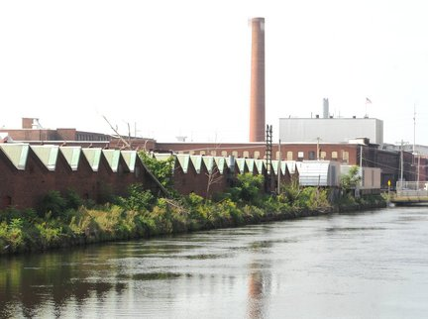
Construction on the site that overlooks the first-level canal will begin by fall and take about two years. The first phase of construction will involve retaining some of the Mastex site buildings and razing others, and will cost an estimated $92 million, Wilson said.
The center itself initially will employ only a dozen to a few dozen people, depending on the estimate.
Wilson, Pluta and others envision that the bonanza would come from spin-off businesses drawn here because of the significance of the center.
“We see a continuous development of jobs in this,” said Wilson, adding also about the center, “Here riddles and problems will be solved.”
Mark M. Murray / The Republican08.09.2010 | HOLYOKE - The former Mastex Industries building.
The project will produce at least a few hundred construction jobs, said Tom Chmura, UMass vice president for economic development.
Mastex made fabric used for airbags, as well as for Armed Forces and industrial uses. The company closed last year and 80 jobs were lost.
In addition to UMass, the other partners in the computing center are the state, the Massachusetts Institute of Technology, Boston University, Northeastern University in Boston and Harvard University, as well as Cisco Systems Inc., of San Jose, Calif., a computer networking giant, and EMC Corp., of Hopkinton, an information storage, backup and recovery firm.
Mastex consists of four properties. The property at 1 Bigelow St., the only one of the four on which taxes and other bills to the city are current, is valued at $572,800 and brings a yearly tax payment of nearly $21,000. At 2 Bigelow St., nearly $325,000 is owed the city in property taxes and gas, electric and other utility bills. The property is valued at $550,200 and would generate $20,159 a year in taxes.
At 3 Bigelow St., nearly $267,000 is owed the city in property taxes and gas, electric and other utility bills. The property is valued at $463,100 and would generate nearly $17,000 a year in taxes.
At a lot on Cabot Street, more than $21,000 is owed in property taxes. The lot is valued at $314,200 and would generate $11,512 a year in taxes.
© 2010 masslive.com. All rights reserved.
Figure 1: Mark M. Murray / The Republican08.09.2010 | HOLYOKE - Governor Deval L.Patrick, center, speaks at Heritage State Park in Holyoke to announce the site of the Holyoke high performance computing center. Looking on are Holyoke Mayor Elaine A. Pluta, left, Congressman John W. Olver (D-Amherst), State Rep. Michael Kane, and University of Massachusetts President Jack M. Wilson, right.
Figure 2: Mark M. Murray / The Republican08.09.2010 | HOLYOKE - The former Mastex Industries building.

